Ex.1: Design a LED Chaser

Circuit diagram -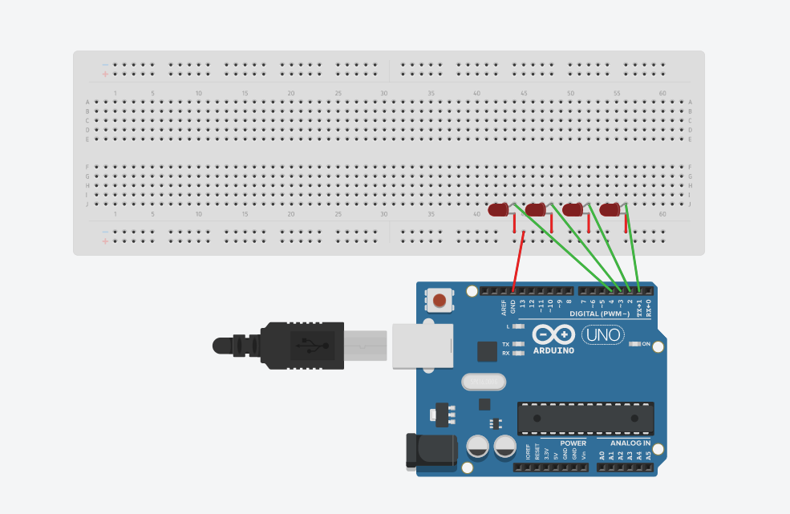

Theory

Concept Used:

1.Lighting LED using Arduino.

2.For loop concept for code.

Description : Build the circuit as shown in the breadboard layout and circuit diagram below. The circuit consists of one LED repeated 4 times. These LEDs and series resistors are connected between Arduino digital pins 1 to 4 and GND.

Learning & Observations:

1.how to use Arduino UNO.

2.How to make LED chaser using Arduino.

3.Using for loop in Arduino coding.

Problems & Troubleshooting:

1.There can be problem with biasedness of LED (anode and cathode).

How to solve it:

The side which has long wire or when we see inside LED there are 2 silver part part which having small portion is anode and the other one is cathode.

Precautions:

1.Connections should be tight.

2.LED’s cathode should be connected to ground and anode to the pin assigned(in above case its 1,2,3,4).

Learning Outcomes:

1.Using Arduino UNO.

2.How to make LED chaser using Arduino.

3.How we can use LED using microcontrollers.

4.Using for loop in Arduino coding.